FALL 2019/20 SCHEDULE
Acrobatics * FDC Enrichment 6-19 * Adult Classes * Shooting Stars 2-7 * Ballet/Pointe
To Register: Please go to our website at www.footworksdancecompany.com
New Students: go to the registration page and enter your registration information (website registrations will open June 7 for priority registration and June 11 to the public).
Returning Students: Go to our website and log into your portals.

A $25 registration fee is assessed to all families billing upon registration and due prior to starting classes.

If you have questions, please call 920-423-7166 or email footworksdancecompany@gmail.com. Classes available as space permits. Classes begin Sept 9, 2018.

We offer $20 referral credits. Refer dancers to Footworks and have them enter your name as to how they heard about us. We look forward to dancing with you!
*all teachers listed are tentative and subject to change as scheduling needs change.
______________________________________________________________________________________________________
Ballet & Pointe
Our ballet program is a progressive & graded program. Often students spend 2 to 3 years at a level for full mastery. Pointe students must be at a level III in ballet, age 12 or older and have the studio director approval. If you are new to Footworks and are interested in pointe, please set up an assessment with our director. Pointe students must take a ballet class or a technique class, along with their pointe class. We recommend a skills level evaluation for new students to Footworks with ballet experience. Bunheads and Level I ballet are open to all dancers in the age group without a skill evaluation.
Classes Begin Sept 9, 2018 and run through our spring recital in May
BALLET AND POINTE
Bunheads (Mon 5:45 – 6:15) ages 3-5 ½ hr
Ms Kim
Ballet I (Tues 6:30-7:30) ages 6 & up ¾ hr
Ms Michelle
Ballet II (Mon 6:00 – 7:00) ages 8 & up 1 hr
Ms Celeste
Ballet III (Tues 7:15 – 8:15) ages 10 & up 1 hr
Ms Brittany
Ballet I, II & III (Tues 4:30-5:30) 9 & up 1 hr
Ms Kim
Ballet IV/V (Mon 6:15-7:15) open 1 hr
Ms Kim
Ballet V/VI (Tues 5:30-6:30) open 1 hr
Ms Kim
-----------------------------------------------------------------------
Pointe I/II (Monday 5:15-6:15) 12 & up 45 m
Ms Celeste
Pointe III (Thurs 7:00-7:45) 13 & up 45 m
Ms Kaylee
Pointe IV (Thurs 7:00-7:45) 13 & up 45 m
Ms Kim

Shoes:
Bunheads (pink leather ballet shoes with elastic strap sewn by the instep)
Level 1 – Level VI (pink leather or canvas ballet shoes with elastic strap sewn by the instep)
Pointe – Pink Pointe shoes fitted properly at “Dance” on College Ave. or with Ms. Kim at Footworks
Attire:
Bunheads, Level 1, Level II, Level II/III
Black, pink or purple leotard (like shown below) and tights. Ballet skirt optional.
Level III/IV
Leotard (like shown below). Ballet skirt and tights optional.
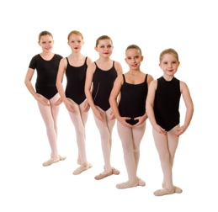
AGES 2 - 7
Attire:
Leotard – any color (tights, dance shorts and ballet skirts are optional)
Pre Dance ‘n Tumble (Wed 5:15-5:45) ages 2 & 3 ½ hr
Pink Leather Ballet Shoes - Ms Nicole
Tippy Tappy Toes (Wed 6:15-7:00) ages 3 & 4 ¾ hr
Pink Leather Ballet Shoes & Black Tap Shoes (with a strap) – Ms Nicole
Tumble Bugs (Wed 5:45-6:15) ages 4-6 ½ hr
Bare Feet – Ms Nicole
Jazz I/Hoppers (Mon 5:00-5:45) ages 5 -8 ½ hr
Tan Leather Jazz Boots – Ms Michelle
Bunheads (Mon 5:45-6:15) ages 3-5 ½ hr
Pink Leather Ballet shoes with elastic strap sewn at instep – Ms Kim

Combos
Tappers ‘n Tutus I (Wed 5:45-6:45) ages 4-6 1 hr
Pink Leather Ballet Shoes & Black Tap Shoes (with a strap)
Ms Kim & Ms Michelle
Tap and Ballet Combo (Wed 4:45-5:45) ages 5 - 8 1 hr
Ms Kim & Ms Michelle
Pink Leather Ballet Shoes & Black Tap Shoes (with a strap)

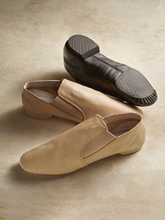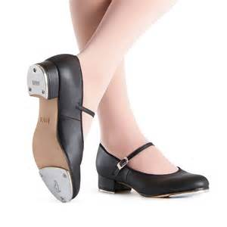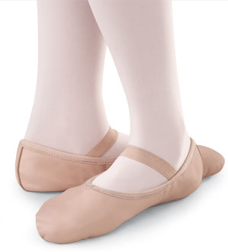

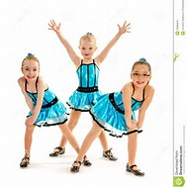

ENRICHMENT CLASSES AGES 5 – 19
FDC Enrichment classes are a graded program, please register for your recommended level.
Jazz 1 (Tues 5:00 – 5:30) ages 5 – 8 ½ hour
Tan leather jazz boots – Ms Michelle
Hip Hop/Jazz Funk (Mon 6:00 – 6:30) ages 7 - 12 ½ hour
Shoes: see instructor – Ms Kaylee
Tap and More! (Thurs 5:00– 5:30) ages 8 & up ½ hour
Black tap shoes with a strap – Ms Jen
Pom and Dance (Wed 6:45 – 7:15) Ages 7 & up 45 m
Tan Jazz Boots – Ms Kim
Combo
Jazz & Lyrical Combo (Mon 6:30 – 7:30) ages 7 & up 1 hour
Tan jazz boots and foot undeez/paws – Ms Kaylee & Ms Celeste
Jazz & Lyrical Combo (Mon 7:30 – 8:30) ages 10 & up 1 hour
Tan jazz boots and foot undeez/paws – Ms Celeste
Tap and Ballet Combo (Wed 4:45 -5:45) ages 5 - 8 1 hr
Ms Kim & Ms Michelle
Pink Leather Ballet Shoes & Black Tap Shoes (with a strap)

Attire:
Leotard/Sports bra – any color (tights, dance shorts, jazz pants and ballet skirts are optional)
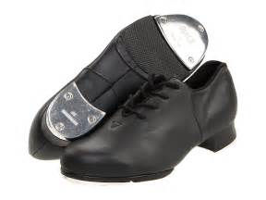

ADULT CLASSES
Adult Tap Thurs 7:45 – 8:15 ½ hour
Black Tap Shoes (style of dancer’s choice) and workout apparel appropriate for tap class –

Adult Jazz/Lyrical Thurs 8:15 – 9:00 ¾ hour
Black Jazz Shoes (style of dancer’s choice) and workout apparel appropriate for Jazz/lyrical class –
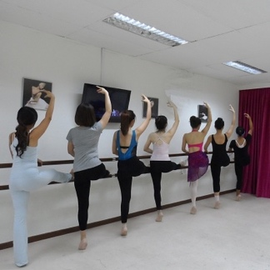

Acrobatics Classes (instructor Ms Nicole)
Tumble Bugs (Wed 5:45-6:15) ages 4-6 ½ hour
Acrobatics I/II (Wed 7-7:30) ages 6 & up ½ hour
Acrobatics II (Mon 7:00-7:45) open ¾ hour
Acrobatics III (Mon 6:15-7:00) open ¾ hour
Acrobatics IV/V (Mon 5:30 – 6:15) open ¾ hour
Attire: bare feet, leotard or unitard (footless tights and dance shorts optional)
Tumble bugs and acrobatics 1 is open to all students within the age limits. Other acro classes will require a skills assessment by Ms Kim or Ms Nicole.

